Salesforce Testing
Integration and performance testing plan for Salesforce connected to incident management
Project: ServiceNow Incident Lifecycle Automation | Phase: Development - Performance Testing

1. Purpose and Scope
This plan applies where Salesforce is connected to the incident solution (for example customer cases creating or updating incidents). It verifies the integration is correct, fast and reliable under load.
In scope:
- Data exchange between Salesforce and ServiceNow (create, update, status sync)
- API response time, throughput and limits
- Error handling, retries and duplicate prevention
Out of scope:
- Salesforce platform configuration unrelated to the integration
- Salesforce licensing and org-wide performance

2. Test Objectives
- Confirm records sync correctly in both directions with the right field mapping.
- Confirm the integration copes with expected and peak volumes.
- Confirm failures are retried or reported without losing or duplicating records.
- Confirm API limits are not exceeded in normal operation.

3. Test Scenarios and Targets
Targets below are proposed starting points. Confirm or replace them with agreed service levels before execution.
ID | Scenario | Metric | Proposed target
SF-01 | Create a case in Salesforce and confirm an incident is created | Correctness, sync time | All mapped fields correct; sync within 1 minute
SF-02 | Update status in ServiceNow and confirm it appears in Salesforce | Correctness, sync time | Status updated within 1 minute
SF-03 | Bulk creation of cases | Throughput, errors | All records processed; error rate under 1%
SF-04 | Send the same case twice | Duplicate handling | No duplicate incident created
SF-05 | Target system unavailable | Retry and alerting | Retries then alerts; no data lost
SF-06 | Sustained API traffic | API limit consumption | Stays within agreed limit with margin
SF-07 | Invalid or missing field values | Validation | Rejected with clear error; logged

4. Test Approach
- Test each integration flow end to end in sandbox environments on both sides.
- Use bulk data loads to measure throughput and find limits.
- Inject failures (timeouts, invalid payloads) to verify retries and alerts.
- Monitor API call counts during runs to confirm limits are respected.

5. Tools
Tool / area | Use
Salesforce sandbox | Safe environment for test cases and data
ServiceNow test instance | Receiving and sending side of the integration
API client | Postman or equivalent for payload checks
Load tool | JMeter or scripts to generate bulk traffic

6. Test Data and Environment
- Sandbox on the Salesforce side and non-production instance on the ServiceNow side.
- Dedicated integration user with least-privilege access.
- Synthetic customer data only.

7. Entry and Exit Criteria
Type | Criteria
Entry | Integration configured on both sides; field mapping agreed; sandbox data prepared.
Exit | All flows verified; throughput and sync time targets met; error handling confirmed; sign-off recorded.

8. Risks
Risk | Mitigation
Sandbox differs from production | Compare configuration before testing and note differences
API limits reached during bulk tests | Schedule bulk tests and monitor consumption
Mapping errors cause bad data | Review mapping with business owners and test boundary values

9. Results Log
ID | Scenario | Result | Pass / Fail | Notes

Process Diagram
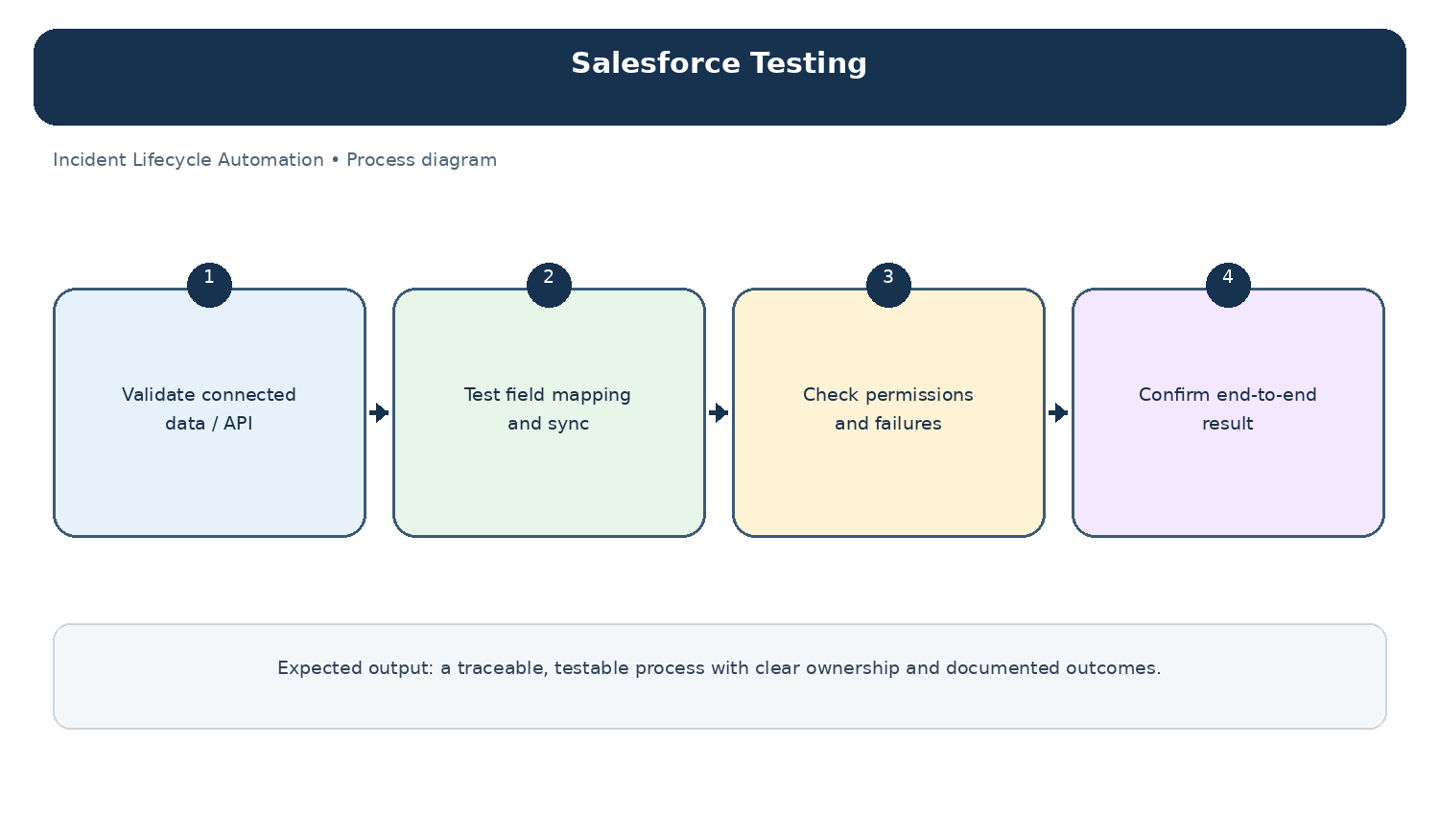
Diagram: Salesforce Testing — project-specific process overview.

